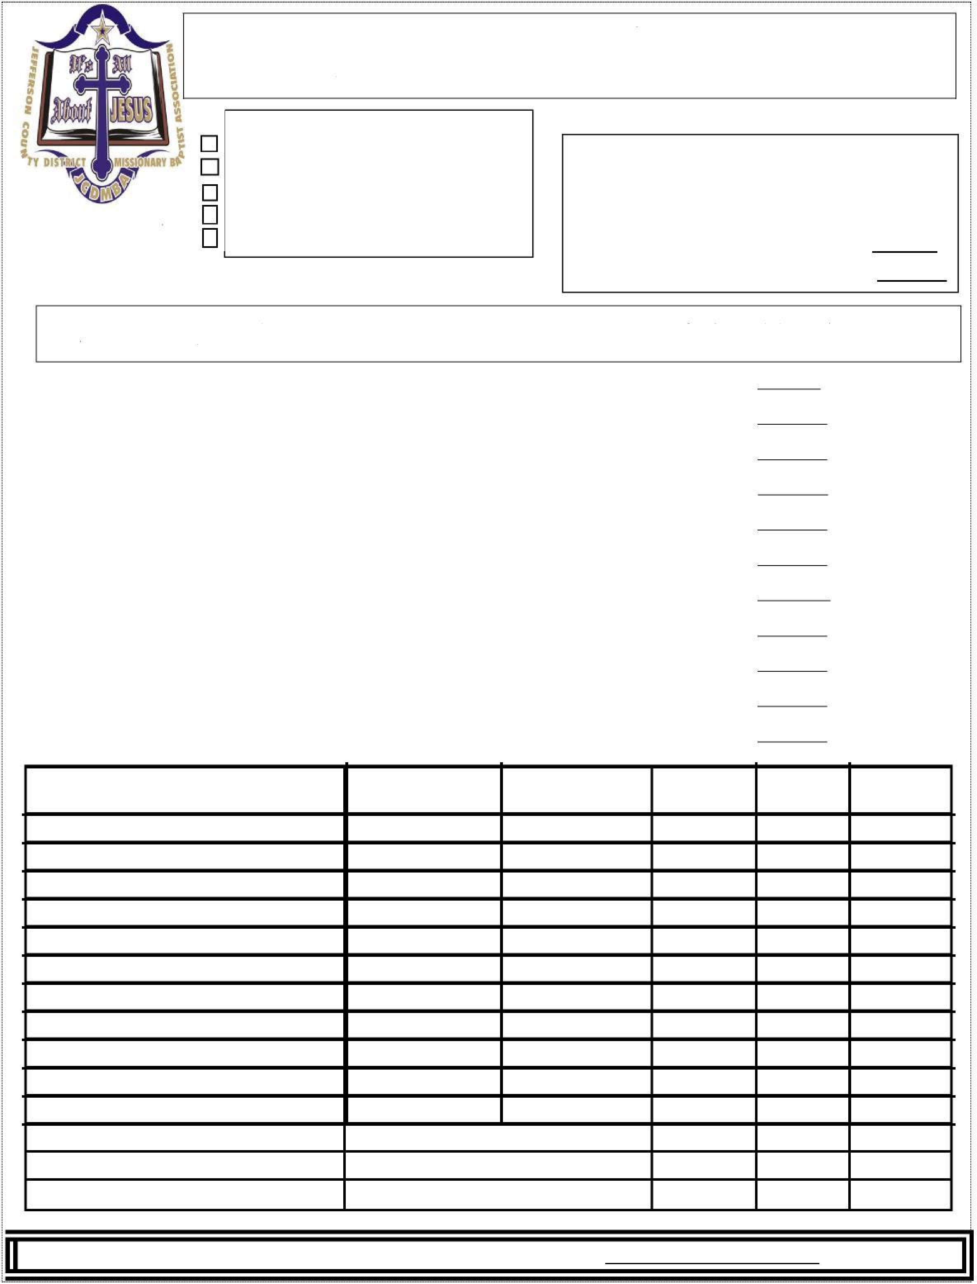

**JEFFERSON COUNTY DISTRICT CONGRESS OF CHRISTIAN EDUCATION**

***Check the applicable box(es)***

**JCDMBA** Church met 2023 Budget Number of Delegates   
**Other** Church or District ($50)

#delegates x $20

**Contribution** (no class $ )

**FOR OFFICE USE ONLY**

***NOTE:*** If a Delegate registers for more than one class, each additional class is an extra $5.00.

Registration #:

Amount Paid: $

*Method of Payment*

Cash ____ Credit Card ____ Check #:

Received by: Date

**DELEGATE COURSE ADD/DROP/CHANGE FORM**

1. This form must be completed and submitted by the person that originally submitted the Registration Form for the church/delegate.
2. Include the assigned registration number from the original registration form. You should   
   have received this in your confirmation email.
3. Pay any additional fees via the any of the above methods. If paying by check, make the

check payable to JCDMBA and note the purpose on the memo line. Mail to:

JCDMBA

2600 Fairfax Avenue

Bessemer, AL 35020

4. You should receive a confirmation of receipt email within 48 hrs. If not, Contact

President Hollingsworth at (205) 602-1375, Dean Hinson at (205) 587-6497 or Dean Shaw at

(205) 960-2482

***Name(s) of Delegate(s) &***

***email address***

**Change To**

***Drop Course***

***Add Course***

***Change From***



For Office Use ONLY: Authorized by: Date: