REGISTRATION INFORMATION  Registration fee for JCDMBA members whose churches are in good standing course cost is $10.00 per course for each course taken. All others registration fees will be $25.00 per course per person. These courses are open to the public especially for those who are looking for COPP courses to further their level of certification.  Thank You for Attending  Jefferson County District  Leadership School 2023  PRE-Registion can be done online at JCDMBA and go to the Congress link on the page. DEADLINE for ONLINE REGISTRATION is November 4, 2023 |  | Jefferson County District Leadership School 2023  November 6-9 & November 13-16, 2023  Time 6:00 p.m. – 8:00 p.m.  at  Friendship Brighton MBC  4819 Main Street, Brighton, Al 35020  JCDMBA Moderator  Dr. Victor Harkins  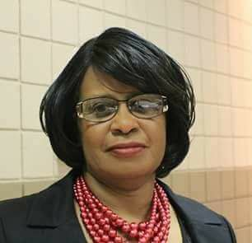  JCDCCE Assistant Dean  Mrs. Catherine Shaw  JCDCCE Dean  Minister Edna Hinson  JCDCCE Acting Dean  Minister Ron Percy  JCDCCE President  Pastor Charles Hollingsworth

November 06-09, 2023  Courses  Course Number Course Title Instructor  1004 Effective Bible Reading Mrs. Debra Whatley  1089 Survey of Romans Mrs. Catherine Shaw  2015 Foundation of Christian Education Dea. Arthur Buie  2023 Creative Ways of Teaching Dr. Calvin Bell  3008 Theology & History of Christianity Mrs. Jerry Mims  6021 Spiritual Formation Minister Ron Percy  9004 Writing Technique I Minister Edna Hinson |  | November 13-16, 2023  Courses  Course Number Course Title Instructor  1001 Introduction to the Bible Dr. Brenda O’Neal  1079 The Gospel of John Rev. William Scott  6013 Organizing the Church for CE Deacon John Dedrick  7010 Introduction to Discipleship Minister Ron Percy  7024 Discovering Your Spiritual Gifts Minister Edna Hinson  8035 The African American Church & Social Justice Mrs. Catherine Shaw  9008 Public Speaking Mrs. Gloria Stanton

